**Product segmentation by turnover: ABC analysis and Demand Variability**

In our analysis we found that the optimal product segmentation method can be done by distributing products according to their turnover rate. We classify the products in three segments, where CLASS A has turnover ratio over 1.5, Class B falls between 1.1 to 1.5, and Class C falls below 1.1.

**1. ABC inventory classification model**

We are using a simple ABC model approach in which products are assigned to Classes **A, B, C** based on their importance to the business. The importance is determined by their sales characteristics which is the highest contribution to the total turnover. The figure below is the result of our analysis of the distribution of products by turnover percentage.

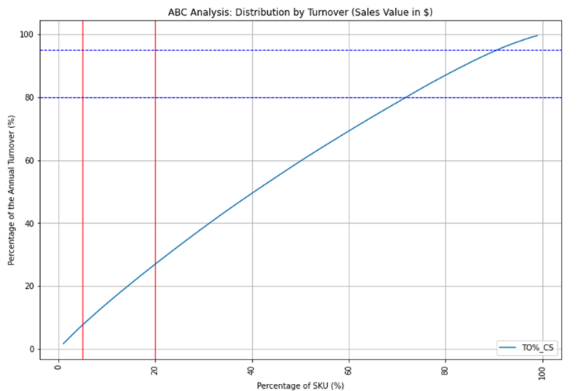

* **Class A:** Most important products. Highest turnover rate group. (4 products found).
* **Class B:** Moderately important products. Second highest turnover rate group (43 products found).
* **Class C:** Relatively important products. Lowest turnover rate group. (48 products found).

**2. Demand Stability: Coefficient of Variation**

Demand variability is a measure of how much variability there is in customer demand. We find coefficient of variance (CV) for products to see how stable customer demand is.

* **Class A:** The red dots, TO% higher than 1.5. CV between 1.5-1.7.
* **Class B:** The green dots, TO% falls between 1.1 to 1.5. CV between 1.5-1.7
* **Class C:** The blue dots, TO% falls between 0.4 to 1.1%. CV between 1.5– 1.7

**3. Conclusion:**

In our analysis we can see almost a uniform distribution of all three classes having close CV ranging from 1.5 to 1.7. This means that all three classes have a **stable demand** without much variability in customer demand. So, we can segment our product according to the percentage of turnover rate. View file **segmentation.csv** to see current product segmentation.